The effect of house prices on long term care market: Evidence from England

Eduardo Gonzalo Almorox[1] [2]

Nils Braakmaann

Volodymyr Bilotkach

John Wildman

First version: January 2017  
This version: May 2017

This paper investigates how house prices affect the market of care homes in England. Local markets where the house prices are high may disincentive the establishment of care homes and suppose a restriction in the access to long term care services. Alternatively, those markets with high prices may also suppose a business opportunity with a greater proportion of wealthier clients willing to pay more for long term care services. Considering the variation of the planning regulations accross local authorities authorities for addressing potential endogeneity in the house prices, our instrumental variables estimates suggest that higher house prices lead to a reduction of the distribution of care homes. Further analyses explore several possible mechanisms driving our results.

**Keywords**: Care homes, house prices, long-term care, England  
**JEL: R31, I12**

**Introduction**

The English housing sector has experienced the fastest growth in prices amongst all OECD countries since the last decades. Between 1997 and 2016, whilst the median individual earnings increased by 68%, the median paid price for residential property raised by almost 260% (Henretty, 2017). A well known consequence from this process has been the crisis of house affordability. Under this crisis scenario, younger homeowners who have entered in the housing market later, struggle to meet the financial conditions[3] to own a house (Hilber and Vermeulen 2010, 2016; Hilber 2017). Other groups who have been in the housing market for longer, such as the old homeowners, are thought to be the beneficiaries of this situation. These gains are based on financial wealth accumulated over time when the properties have increased their value. However, these gains are also subject to the decision of the old homeowners to sell their properties and live in a cheaper area (Hilber and Schöni, 2016; Hiller and Lerbs, 2016).

At the same time, the demand for long term care services that involve health care and help with activities of daily living has also increased substantially. In England, the proportion of people with at least one difficulty goes from 16.4% when they are 65 to almost 50% when they are 85 (AgeUK, 2017). In addition to the aging of the population, several societal changes shift the supply towards a paid formal provision by nursing and residential care homes. Old homeowners who require care, are the main receptors of long term care services.

In this article, we investigate the relationship between the housing and long term care markets. Although the increase of house prices may improve the financial wealth of old homeowners, it may also lead to restrict the choices of potential care services that they may require. We provide evidence about the causal link between the level of house prices on the availability of care homes that provide long term care services.

The direction of effect may be a priori unclear. House prices may be related to the composition of potential payers for the services offered by a care home (Danton et al, 2010). Thus, areas with higher house prices may reflect greater levels of affluence and a likely proportion clients willing to pay more for the fees of long term care services. In these cases, care providers may have the incentive to establish their care homes in these areas. However, this situation may also result in an unequal distribution of long term care across different areas depending on the level affluence.

Alternatively, high house prices may suppose a fixed cost when providers decide to build their facilities in an area. Higher house prices may then represent an important barrier that restricts the entry of care homes in those areas. Besides, higher house prices may also increase the opportunity costs of alternative building projects and therefore provide an incentive to deter the development of care homes.[4] A likely consequence derived from the former is that long term care choices available are reduced for those people living in these areas.

Our results reveal that high house prices affect negatively on the number of care homes available. A potential problem of the analysis is that long term care providers may choose local markets on the basis of unobservable variables that also affect the level of house prices. If this occurs, the choice of markets is not necessarily random and the estimated effects of the house prices may be biased. To overcome this potential limitation, we use an identification strategy based on Hilber and Vermeulen (2016) that exploits the variability in the the level of restrictiveness associated with planning regulations across English districts. The main difference in comparison with this approach, is that we use the information about planning regulations as an instrument for the house prices. For our analysis, we construct a dataset that combines information on care homes, house prices and urban planning decisions corresponding to 315 local authorities from 2011 to 2016.

This paper contributes to the growing literature on the study of the residential long term care market in England. To the best of our knowledge, this is the first study that provides causal evidence with regards to the effect of house prices on the proportion of care homes at local level. Other papers have shown how the house prices are related to other aspects of the long term care market. Forder and Allan (2014), using cross-sectional data, provide a detailed analysis of elements that determine the competition amongst care homes and assess the consequences of this competition in both prices and quality. They show a negative relationship between the prices paid for the services of a care home and the prices of the houses of nearby. Likewise, they show a positive relationship with the probability of a care home obtaining greater level of quality. In second stage of our analysis we assess the impact of house prices on the proportion of care homes depending on their quality standards obtaining similar results. However, although the is positive and significant, it is very low in terms of the magnitude. Other authors, have explored the dynamics of the market by analysing potential elements that may lead to care homes closures. Neten et al. (2003, 2005) find that prices have a negative relationship with closures and Allan and Forder (2015) show that poorer quality and more competitive markets are elements that increase the probability of exit from the market.

We extend this literature by addressing issues referred to the entry process of care homes in local markets. Prior to this paper, only Machin et al (2002) have provided some empirical evidence of factors affecting the market entry in the context of a minimum wage regulation. Their results suggest that the introduction of the minimum wage affects negatively the entry of care homes. However, this effect seems to be not significant. In addition to providing a more up to date evidence, our paper uses a more extensive dataset provided by the regulator, the Care Quality Commission (CQC). Likewise, this research also extends the literature that studies the effects of the high house prices in England using the care homes as a sector for the analysis.

This paper is organised as follows. Next section, section 2, outlines the main institutional characteristics that characterise the long term care and housing markets. Section 3, describes the data used for the analysis and section 4 presents the econometric model and the empirical strategy to address potential empirical concerns. Section 5 discusses the results and section 6 concludes.

**English local government**

In England, urban planning and long term care are responsibility of local governments. Local authorities may be organized according to two main operational systems: one tier or two tier. Two tier systems are composed by county and district councils. County councils are the upper tier and cover wider geographical areas. District councils, on the other hand, are the lower tier and comprise more local matters. Normally, the activities managed by both councils are different although in some cases may overlap. One tier systems involve unitary authorities that are responsible for the provision of all the activities at local level. Unitary authorities may have two special subcategories that include the metropolitan boroughs and London boroughs.[5]

Taking into account the former main categories, England has a total of 353 local authorities that include 27 county councils, 201 district councils and 125 unitary authorities.

Long term care is managed 152 local authorities that operate at council level.[6] The main responsibility entails the commissioning (e.g. the purchase) of services for those clients eligible for public support. Since the mid-eighties, the provision of long term care operates according to market mechanisms. As a result, the *for profit* private sector has emerged as the main provider. In 2014 a 74% of the total places belonged to a private provider against 8% ruled by the public sector. The remaining 18% of the places were provided by the voluntary sector (Jarret 2017).

There are 19 private and 6 voluntary providers that own about a 30% of the beds available. Within these, 4 “main providers” are big chains that concentrate a 15% of the market share. The remaining 70% of the market share is composed by providers that have a reduced number of beds - no more than 0.4% of the beds each. Despite being very fragmented, the market for care homes presents in general a high level of competitiveness. This competitiveness presents notable differences across local authorities .[7]

One explanation for these regional discrepancies corresponds to the composition of long term care recipients in each local authority. Hence, care homes may have two types of clients depending on how they fund their services. Private clients purchase and self fund their care according to market rules and their willingness to pay for different types of services. Likewise, there are also clients whose care is partially or fully funded by the local authorities. The eligibility and degree of this public support is based on a means-test that assesses their financial capacity. The market for this type of clients works as a quasi market in which the local authorities purchase the long term care services to private providers on behalf of the clients (Le Grand, 1991)[8]. The proportion of publicly funded clients is notably superior in comparison self-funded clients.[9].

The fact that local authorities have to purchase care on behalf of a significant part of the demand, suggests that they may have certain buyer power when negotiating the fees applied to public funded clients. A consequence of the former is the potential cross subsidisation of privately funded clients in favour of the publicly supported. These situation has been documented both in the English long term care market (OFT, 2005; Hancock and Hviid, 2010; Forden and Allan 2014) and in the US (Mukamel and Spector, 2002; Gravowski 2004).

Unlike long term care, urban planning is managed at district level. The planning system entails activities aimed at meeting various strategic priorities for the areas that compose the district. These priorities are set out in the National Planning Framework - a national framework aimed at guiding policies that entail development decisions for meeting local needs and involve the fulfilment of local needs at socio-economic, cultural, security and health level.

The design of local planning policies has been regarded as one of the main drivers that constrains the housing supply and leads to increases in the house prices. In addition of being more restrictive than other countries (Cheshire 2009, Hilber 2015), English planning regulations are complex. For example, owners of some areas may have more incentives to promote “not in my backyard” policies that restrict the local development. The underlying rationale for that is that these tighter regulations lead to increases in the land value of those areas already developed. Conversely, for those owners in less developed areas, these policies imply a cost (Hilber and Robert-Nicoud, 2013).

In figure 1 we present evidence about the greater capitalization of the house values in more restrictive areas. Particularly we show positive association between the house prices and the historical of refusal of major projects.

[INSERT FIGURE 1 ABOUT HERE]

Besides the level of house prices has not evolved evenly across the different regions in England. Figure 2 plots the evolution of the average real house prices over the last two decades. Areas located in the South East, East and South West, in addition to London, have registered the higher increases.

[INSERT FIGURE 2 ABOUT HERE]

The effects of planning regulations have been studied also in other activities such as the retail sector for the UK (Griffith and Harmgart (2008), Haskel and Sadun (2012), Cheshire et al (2015), Sadun (2015)), France (Betrand and Kramarz (2002)), Italy (Schivardi and Viviano (2011)) or Spain (Sanchez Vidal, 2015)

**Data**

We use data corresponding to 315 local authorities that operate at district level. Data are collected from different sources and concern the period from 2011 to 2016. We divide into three time intervals that include March 2011 – March 2013, March 2013 – March 2015 and March 2015 – September 2016.

Our main variable is the number of care homes per 1000 population that are aged 65 or over in the local authority. This variable is based on Tokunaga and Hashimoto (2011) who analyse the entry of private providers in Japanese long term care markets using a similar variable to reflect providers’ choice.

## **Care homes**

Information concerning the characteristics of care homes is obtained by the CQC directory of active and inactive care homes[10]. This dataset contains all the registrations of care homes that have carried out a regulated activity since 2010. The initial sample includes 24,354 records. We restrict our analysis to the entries from March 2011 onwards since a substantive proportion of the total registrations (16,054) that were carried out during 2010 and the first two months of 2011 were the result of legal requirement[11]. Our final sample is referred to 8,300 care homes.

A key advantage of this dataset is that it contains information about the entries and exits of the care homes in the market. Given that we do not have any further information available, we assume that care entry in a market since the date they are registered. Similarly, we consider they exit the market when they deregister. For determining our dependent variable, we compare the number of care homes that remain in each local authority for each time interval. In our analysis we focus on records associated with a new activity. These are different to new registrations that change the identification code due to organisational reasons (e.g. changes in the address or take overs from a different provider)[12].

This dataset provides further information that includes the number of beds in each care home, the postcode and postal address, the city and region where the care home is located as well as the local authority that a council level is responsible for the social care services corresponding to the location of the care home. Likewise, with the exception of the number of beds, the same information is available with regards to the 3,830 providers where the care homes of our sample belong to.

In the second stage of our analysis we use information corresponding to quality ratings derived from the system implemented by the CQC since 2014. On the basis of five dimensions[13], this new approach set a systematic method for collecting evidence that enables a more consistent assessment and comparison of the care homes’ performance. Services are rated according to four categories: *outstanding, good, requires improvement or inadequate*. For our analysis we collapse these categories into two: bad (requires improvement and inadequate) and good (outstanding and good). Because the information is only available since October 2014, this part of the analysis considers a different timeframe that involves three waves October 2014 - May 2015, May 2015 – February 2016 and February 2016 – September 2016.

## **House prices**

The information corresponding to prices of the properties is obtained from the price paid dataset released on a monthly basis by the Land Registry. This dataset contains all the transactions of properties carried out in England and Wales since 1995. In addition to the price paid for the transaction, the dataset includes further information such as the type of property, the address, the city, district and region where the property is located as well as whether the location was newly built and whether the property was under leasehold or freehold[14]. The information referred to transactions is collected on a daily basis. We subset the transactions that correspond to each local authority and obtain the average price.

**Instruments**

Our identification strategy uses information associated with several supply constraints. In order to capture the regulatory restrictiveness, we use the rate in change of delay of major projects which that is obtained from the Department of Communities and Local Government (DCLG). This variable compiles the number of decisions that have delayed projects for more than 13 weeks over a year. Besides, we also use the variation in the historical political composition of the local authorities. On the basis of Hilber and Vermeulen (2016), our analysis captures the historical Labour vote share at the General Election since 1983 for each local authority. The information is collected by British Election Studies Information System. In order to control for possible bias of associated this measure, we also include data on share of Labour vote corresponding to general election of June 2015. Data are obtained from the Parliament website platform.[15]

Regarding the information associated with physical constraints that may determine the housing supply we use historical population of density in 1911. This variable is used as an instrument to correct for potential endogeneity associated with the share of developable land. Table 1 shows summary statistics for the variables of the baseline sample.

[INSERT TABLE 1 HERE]

On average, over the period of analysis there were about 1.7 care homes per 1000 population over 65. Yet, this proportion varies across the different local authorities. Figure 2 plots the spatial distribution of care homes for all the local authorites. In general, neighbouring districts present a similar proportion of care homes. There are some exceptions corresponding to some districts in the North West and Central North where the distribution of care homes is between 2 and 4 care homes per 1000 people over 65.[16] Local authorities located in the south of the country (mainly in the South West and South East regions) have the greater amount of care homes per old population.

[INSERT FIGURE 2 HERE]

Figure 3 shows the spatial distribution of house the prices. It is possible to appreciate a clear dichotomy between local authorities situated in the north and in the south of country. Also, there some extreme cases of local authorities where the average value in the properties registers a maximum £2,170,757. Apart from this outlier, the average house price of the sample is £268,764.

[INSERT FIGURE 3 HERE]

**Empirical strategy**

The purpose of our analysis is to study empirically the effects of the house prices on the proportion of care homes in local long term care markets. The regression is based on the following specification

Where Eq. (1) indicates the relationship between the proportion of care homes per 1000 population over 65, , in a local authority in a time period and the average of the house prices, . represents an error term that is identically and independently distributed. Equation (1) can be estimated by OLS and the parameter of interest,, may be interpreted as a causal effect of the house prices, only if is exogenous so that ,. Nonetheless, as we have outlined in the introduction, house prices may be endogeneous to unobservable factors which may also determine the proportion of care homes in an area. If the influence of these potential unobservable variables is not appropriately undertaken, the OLS estimations of may be inconsistent.

An example that may illustrate the latter could be an unobserved shock that affects positively the values of the properties and also incentivise the entries in the market given likely wealth effects. Hence, higher level of housing prices may result in wealth effects that lead to greater levels of consumption and then attract businesses. This implies that the selection of an area by a care home provider is likely to be *known* and then non-random. In this case the effect of may be associated partially with . Likewise another potential problem can be associated with the reverse causality between the number of care homes and the level of house prices. Care homes may be considered an amenity that increases the quality of the neighbourhood and potentially the values of the properties in an area.

In order to tackle with these problems associated with , we may use an instrumental variable that is uncorrelated with but is correlated with . Our identification strategy is based on Hilber and Vermeulen (2016). These authors take advantage of the variability in restrictiveness of local planning regulations for analysing the effects of supply constraints on house prices. Their findings confirm the vision that tight supply regimes – e.g. with more regulatory constraints in the planning regulations, lead to increases in the prices. In our case, however, we apply the planning regulation variables as direct instruments to the house prices. For our identification we assume that this instrument, in addition to being correlated with the local earnings, is also correlated with the house prices (see Figure 1).

A variable used by Hilber and Vermeulen to indicate the planning restrictiveness is the rate of refusal of major projects. Despite being a well-established variable in the literature (refs) they highlight at least to potential problems that may result in bias. A first source for bias is referred to the procyclical nature of the rate of refusal. Also, it may be problematic that developers do not apply for project in certain local authorities if they know in advance that they are restrictive. For these cases the observed refusal rates may not reflect realistically the level of restrictiveness. In order to address this limitation it is possible to employ two identification strategies.

The first involves a planning reform aimed at speeding up the planning processes and the second links the planning regulations and the variation in the share of local political power. The main idea of the first identification strategy consists of using the variation in the change in the delay rates before and after the reform. Set in 2002, this reform included the establishment of an explicit goal for concluding major development projects. The rationale was to avoid the delays of major projects. Local authorities were not formally penalised for not meeting the target but they had good incentives to reach it. Funds from the central government could be retained otherwise. Local authorities could still meet the target by approving smaller projects and refusing greater projects that were more difficult to be finished on time.

The former suggests that local planning authorities could have a different behaviour before and after the reform. Before the reform, more restrictive local authorities would have more delays and the least likely to meet the target. After the reform, these local authorities would more likely to refuse more projects and therefore suffer less delays. Meanwhile, less restrictive local authorities would not have to alter their behaviour substantially after the reform. On the basis of the former, we allow for a 10-year period to represent the average delay rates pre and post reform. Hence we use the delay rates 1994 and 1996 and the delay rates between 2004-2006.

The second strategy consists of exploiting the relationship between the political composition of local councils and the application of local planning regulations. In addition to Hilber and Veemeulen (2016), similar strategies have been used by other authors such Bertrand and Karmaz (2002) or Sadun (2008) for addressing the endogeneity associated with planning decisions. As introduced before, we use the historical share of Labour party since the General Election of 1983. We choose the share of Labour voters since the attitudes of these voters regarding construction will be more on the basis of the job implications and inclined to grant house access rather than to preserve the value of the properties. We could have used the results derived from local elections. However, given the local nature of planning decisions, these have the risk of being correlated with the development of local housing market. The time frame of 1983 provides the earliest date where election results can be linked to data corresponding to local authorities.

Physical constraints may also restrict the supply of houses. In addition to the topography, the share of developed land can be thought as an example of those. A potential limitation referred the share of developed land is that the availability (or scarcity) of this type of land implies opportunity costs that can transmitted to the house prices. These can be a source of bias. For addressing this problem, the historic density of the population density can reflect earlier forms of agglomeration and used for identifying the share of developable land since. Hence, we use the density of population in 1991 as an instrument for the share of developable land.

Considering these caveats, we specify Eq. (2) in order to estimate the first-stage fitted values of the house prices. The predicted values derived from this equation are used then in Eq. (2) for getting a consistent estimate of

where refers to the variable associated with the planning regulation (e.g. the rate of refusal of major projects) and to the variable referred to the physical constraint (e.g. share of developed land). An In addition to the specification developed by Hilber and Vermeulen (2016), we include as a control for the contemporaneous share of Labour voters for each local authority. We introduce this variable in order to control for unobserved trends that may affect the historical share of labour voters. For example, some areas may have received the inflow of certain residents that have changed the demographic composition and the voting behaviour.

The main difference of our approach in comparison to the strategy developed by Hilber and Vermeulen (2016), is that use two instruments for identifying the house prices rather than a single instrument for identifying variables that determine them such as the planning regulations and the share of developed land.

Table (2) shows evidence on the validity of the instruments. Considering the regression specified in Eq. (2), columns (1) and (2) present the estimates corresponding to the change in the rate of delay and the local share of Labour voters respectively. The results associated with these estimations point at the direction that we would expect. Greater changes between the delay rates pre and post reform, influence negatively the house prices. Bigger differences indicate greater reductions in the rates of delay. As we explained before, less delay rates would be substituted with more rejections of the major projects in the case of more restrictive local authorities. Likewise, the share of Labour voters is also associated with lower levels in the house prices. Column (3) includes the estimation results considering only the density in the population in 1911 as the single instrument and column (4) includes all the instruments.

[INSERT TABLE 2 HERE]

The bottom of Table (2) shows various tests that assess validity of the instruments. First, we evaluate the strength of the correlation between the instruments and . The join test of excluded instruments is highly significant at at a lower level than 0.01 in all the cases. On the same basis, we also present the results of weak instruments test using a Cragg Donald Wald statistic and a Kleibergen-Paap Wald rk statistic. The results yielded by these tests suggest that weak instruments do not seem to be a problemd in our regressions.

Second, since our estimations use in some cases various instrumental variables for identifying a single endogenous variable, we present the results of over-identification tests based on Sargan (1958)[17]. The referred to the statistic considering the rate of refusal and the share of Labour voters (columns (2), and (4) respectively) are lower than 0.01. This suggests the rejection of the null hypothesis of valid over identification restrictions and raises a caveat when interpreting the results derived from these specifications since not all the instruments may be identifying the the same vector of parameters.

**Results**

## **House prices and care homes**

Table (4) reports the main results of our baseline model based on Eq. (1) in which we estimate the effect of house price on the proportion of care homes.

[INSERT TABLE 3 HERE]

The results reported in column (1) show OLS estimates that indicate a negative relationship between the house prices and the distribution of care. Figure (6) illustrates this association which is negative and significant at the 1% level. As discussed before, these estimates should not be read as a causal link. This is because there may be factors affecting the level of house prices that also affect the decision of long term care providers to choose those locations.

[INSERT FIGURE 6 HERE]

Next columns present IV estimates using different combinations of the instruments. The coefficients derived from all the IV specifications suggest that higher prices in the housing markets affect negatively the number of care homes. Column (2) and (3) presents results using the delay rate and the labour share in conjunction with the historical population density respectively. The effect using the rate of delay and the historical population density (-0.33) is significant at the 1% level. The effect without considering the influence of regulation constraints is greater (-0.42) and also significant at the 1% level.

A potential concern is that the decision of entry in the market may be lagged to certain extent. For instance, providers may determine their decision of entry in a local market considering the historical house prices. Also, another potential problem is the influence of care homes on the value of the properties in an area. They may suppose and amenity that future inhabitants may value and thus affect the prices of the properties in the area. To mitigate these potential limitations, Table (4) show the effects of house prices that are lagged two years. The effects using the lagged prices are along the same lines as the findings presented in Table (3).

[INSERT TABLE 4 HERE]

In Tables (5) and (6) we explore the robustness of our results adopting various changes in the sample. Firstly, we assess the potential influence of outliers in the number of care homes. Thus, we remove from the sample those local authorities that have the top and bottom 5% of the care homes in the market (94 care homes in total). Table (5) display the results of these estimates.

[INSERT TABLE 5 HERE]

The IV estimates (columns (2) to (5)) present heterogeneous effects. Particularly, in the regressions using the share of Labour votes, the effect of the house prices on the distribution of care homes is positive. Given the value of the Hansen J statistic, it is possible that these specifications could be identifying other parameters than the house prices. The specifications with the remaining instruments, the change of the delay rate and the population density in 1911, provide negative effects. However, now these effects are not statistically significant. These findings suggest that that our results could be driven by the extreme values of the sample.

Likewise, we also consider a sample without those care homes that are associated with planning authorities in the region of London (96 care homes). As we reflected in Figure (1), the house prices in this region have experienced the greatest increase during the last two decades. The results from this analysis are presented in Table (6). Compared to previous analysis in Table (5), the estimates derived from the regressions instrumenting with the rate of delay and the population density report greater effects that are significant at less than 5% level.

[INSERT TABLE 6 HERE]

In general, these findings suggest that the decision of entry by long term care providers in local markets may respond mainly to financial incentives that determine the cost of development. The development of a care home in an area where the value of alternative uses of land such as housing are high, also entails a high opportunity cost. If this argument holds, given the positive relationship between the level of planning restrictiveness and value of the properties, more restrictive planning areas would imply higher opportunity costs and therefore the negative effects of the prices on the entry of care homes should be more pronounced.

## **Alternative mechanisms**

We explore the former argument by carrying out the analysis in two samples that gather local authorities according to their level of restrictiveness in the planning decisions. We select each group of planning authorities on the basis of their behaviour before and after the reform that imposed particular planning targets. In Figures (6) and (7) we represent the distributions of refusal rates and prices for local authorities depending on the change in their rate of delay before and after the reform.

[INSERT FIGURE 6 HERE]

[INSERT FIGURE 7 HERE]

Tables and (7) and (8) report the effects of house prices on the the care homes depending on whether the local authorities were delaying equally or more after the reform (e.g. non restrictive), or less (e.g restrictive).

[INSERT TABLE 7 HERE]

[INSERT TABLE 8 HERE]

In more restrictive local authorities, we find a negative and significant effect from the prices compared to no restrictive local authorities. As introduced before, a reason behind these findings would be the greater opportunity costs associated with the alternative uses of land in this more restrictive planning authorities.

Providers also could be focused on more affluent areas aiming at securing potential clients that do not rely on public funding arrangements. A potential explanation may be the purpose of providers for ensuring a level of clientele that helps them to offset costs. These would not be only associated with the entry and development of care homes in a local market. Also, they would be related to the existing cross-subsidisation from self-funded to publicly supported clients. Humphries et al (2016) argue that this strategy is followed by a number of long term care providers in order to preserve their financial viability and overcome the funding crisis. This argument would suggest that areas with a greater proportion of clients that self fund their care should be more attractive for care homes.

Exploring this mechanism would require information on the composition of the clientele associated with each care home. Unfortunately, this information is not publicly available. However, a proxy for the composition of the clientele can be derived from the quality rating associated with the care homes. It is sensible to think that people who self-fund their care may have more willingness to pay for greater levels of quality. Care homes with an outstanding level of quality are likely to have a greater proportion of clients that self fund their care.

[INSERT TABLE 9 HERE]

[INSERT TABLE 10 HERE]

Tables (9) and (10) report the results of the effect of house prices on the number of care homes according to their level of quality. The IV estimates (columns (2) to (5)) reveal a positive effect of the house prices on the number that obtain an outstanding rating (Table (9)). Although these effects are small, possibly because of the reduced proportion that this type of care homes represent out of the total, they are significant at a level less than 5% when instrumenting with the share of Labour voters and all the instruments. Regarding the number of care homes with a bad rating, the effect is also positive and greater, but not significant for any of the IV estimates. These findings suggest that effectively care homes would be addressing their market strategy to those markets where there is a higher proportion of potential self-funded clients.

**Conclusion**

The results suggest that high prices in the housing markets are a social cost and reduce the number of care homes. The findings appear to validate the idea that the development of care homes would be driven by financial forces. According to these, alternative development projects would be more attractive than care homes. Given the importance of those observations in the extremes of the sample, our results should be read as suggestive rather than definitive. A potential avenue for further research might consist of exploring the results in these local authorities.

This paper provides evidence of the impact of the English housing market on adult long term care. It is the first that does so by tackling explicitly with the endogeneity problems associated with the house prices. The availability of information on planning regulations offers a unique opportunity to address them. This paper contributes to the literature aimed at studying the connection between the housing market and the market of long term care activities. These findings may contribute to improve the coordination between local authorities for the design of both planning and social care policies.

**Tables**

Table 1: Summary statistics

|  |  |  |  |  |  |
| --- | --- | --- | --- | --- | --- |
|  | Obs | Mean | Minimum | Maximum | St.Dev |
| Care homes per 1000 population over 65 | 945 | 1.6678 | 0.4255 | 4.0611 | 0.5416 |
| Average house prices | 945 | 268,564 | 91,157 | 2,170,757 | 179,558 |
| Share of Labour voters 2015 | 945 | 0.2810 | 0.0698 | 0.7301 | 0.1448 |
| Rate of delay change | 945 | -0.0376 | -0.6345 | 0.5310 | 0.2197 |
| Historical share of Labour voters | 945 | 0.1625 | 0.0010 | 0.4103 | 0.0886 |
| Proportion of care homes (bad quality) | 945 | 0.1905 | 0.0000 | 0.6585 | 0.1232 |
| Proportion of care homes (outstanding quality) | 945 | 0.004095 | 0.0000 | 0.0870 | 0.012 |
| Population density in 1911 | 945 | 774.7089 | 3.2504 | 22,028.8 | 2,633.387 |

Table 2: First stage results – dependent variable average house prices (log)

|  |  |  |  |  |
| --- | --- | --- | --- | --- |
|  | (1) | (2) | (3) | (4) |
| Rate of delay change | -0.561*** |  |  | -0.322*** |
|  | (0.0853) |  |  | (0.0703) |
| Share of Labour voters |  | -2.312*** |  | -2.159*** |
|  |  | (0.341) |  | (0.327) |
| Population density 1911 | 8.15e-05*** | 0.000103*** | 8.07e-05*** | 0.000102*** |
|  | (1.11e-05) | (1.25e-05) | (1.22e-05) | (1.18e-05) |
| Observations | 945 | 945 | 945 | 945 |
| Number of local authorities | 315 | 315 | 315 | 315 |
| F(excluded instruments) | 47.26*** | 58.04*** | 43.85*** | 53.81*** |
| Cragg-Donald Wald F statistic | 192.834 | 392.101 | 261.942 | 288.52 |
| Kleibergen-Paap Wald rk F statistic | 47.264 | 58.043 | 43.854 | 53.81 |
| Hansen J statistic | 1.918 | 10.117*** |  | 10.201*** |

Note: The IV regressions using the historical share of Labour voters also include the last share of Labour voters in June 2015. Robust standard errors are presented in parentheses. Standard errors are clustered at local planning authority level. ***/**/* denote significance levels at 1%, 5% and 10%.

Table 3: Second stage results – effects of house prices on care homes entry

|  |  |  |  |  |  |
| --- | --- | --- | --- | --- | --- |
|  | (1) | (2) | (3) | (4) | (5) |
| Average house prices (log) | -0.270*** | -0.332*** | -0.188** | -0.414*** | -0.190** |
|  | (0.0597) | (0.0965) | (0.0938) | (0.0913) | (0.0920) |
| Estimation | OLS | IV | IV | IV | IV |
| Observations | 945 | 945 | 945 | 945 | 945 |
| Number of local authorities | 315 | 315 | 315 | 315 | 315 |
| F | 51.27*** | 11.80*** | 2.128 | 20.45*** | 2.22 |
| R-squared | 0.052 | 0.049 | 0.053 | 0.037 | 0.0531 |
| Rate of change delay |  | ✓ |  |  | ✓ |
| Share of Labour voters |  |  | ✓ |  | ✓ |
| Population density |  | ✓ | ✓ | ✓ | ✓ |

Note: The IV regressions using the historical share of Labour voters also include the last share of Labour voters in June 2015. Robust standard errors are presented in parentheses. Standard errors are clustered at local planning authority level. ***/**/* denote significance levels at 1%, 5% and 10%.

Table 4: Lagged prices

|  |  |  |  |  |  |
| --- | --- | --- | --- | --- | --- |
|  | (1) | (2) | (3) | (4) | (5) |
| Average lagged house price (log) | -0.250*** | -0.357*** | -0.193* | -0.469*** | -0.196** |
|  | (0.039) | (0.107) | (0.0994) | (0.0994) | (0.0976) |
| Estimation | OLS | IV | IV | IV | IV |
| Observations | 945 | 945 | 945 | 945 | 945 |
| Number of local authorities | 315 | 315 | 315 | 315 | 315 |
| F | 41.73*** | 38.93*** | 58.35*** | 34.60*** | 50.45*** |
| R-squared | 0.042 | 0.035 | 0.048 | 0.010 | 0.048 |
| Cragg-Donald Wald F statistic |  | 157.422 | 384.978 | 202.022 | 280.486 |
| Kleibergen-Paap Wald rk F statistic |  | 38.926 | 58.353 | 34.604 | 50.451 |
| Hansen J statistic |  | 2.438 | 10.227*** |  | 10.328*** |
| Rate of change delay |  | ✓ |  |  | ✓ |
| Share of Labour voters |  |  | ✓ |  | ✓ |
| Population density |  | ✓ | ✓ | ✓ | ✓ |

Note: The IV regressions using the historical share of Labour voters also include the last share of Labour voters in June 2015. Robust standard errors are presented in parentheses. Standard errors are clustered at local planning authority level. ***/**/* denote significance levels at 1%, 5% and 10%.

Table 5: Robustness check – top and bottom 5% excluded

|  |  |  |  |  |  |
| --- | --- | --- | --- | --- | --- |
|  | (1) | (2) | (3) | (4) | (5) |
| Average house price (log) | 0.148*** | -0.0105 | 0.0669 | -0.0906 | 0.0703 |
|  | (0.0328) | (0.128) | (0.115) | (0.160) | (0.109) |
| Estimation | OLS | IV | IV | IV | IV |
| Observations | 851 | 851 | 851 | 851 | 851 |
| Number of local authorities | 299 | 299 | 299 | 299 | 299 |
| F | 20.21*** | 61.49*** | 59.03*** | 81.00*** | 50.14*** |
| R-squared | 0.023 | 0.020 | 0.020 | 0.020 | -0.024 |
| Cragg-Donald Wald F statistic |  | 93.197 | 219.308 | 91.879 | 165.180 |
| Kleibergen-Paap Wald rk F statistic |  | 61.494 | 59.034 | 80.996 | 50.136 |
| Hansen J statistic |  | 0.452 | 5.641** |  | 5.620* |
| Rate of change delay |  | ✓ |  |  | ✓ |
| Share of Labour voters |  |  | ✓ |  | ✓ |
| Population density |  | ✓ | ✓ | ✓ | ✓ |
| Note: The IV regressions using the historical share of Labour voters also include the last share of Labour voters in June 2015. Robust standard errors are presented in parentheses. Standard errors are clustered at local planning authority level. ***/**/* denote significance levels at 1%, 5% and 10%. | | | | | |

Table 6: Robustness check – London region excluded

|  |  |  |  |  |  |
| --- | --- | --- | --- | --- | --- |
|  | (1) | (2) | (3) | (4) | (5) |
| Average house price (log) | 0.232*** | -0.360* | 0.477 | -0.868** | 0.175 |
|  | (0.0328) | (0.128) | (0.115) | (0.160) | (0.394) |
| Estimation | OLS | IV | IV | IV | IV |
| Observations | 849 | 849 | 849 | 849 | 849 |
| Number of local authorities | 283 | 283 | 283 | 283 | 283 |
| F | 23.68*** | 32.81*** | 12.08*** | 23.88*** | 13.56*** |
| R-squared | 0.027 | 0.019 | -0.179 | -0.177 | -0.051 |
| Cragg-Donald Wald F statistic |  | 68.589 | 20.776 | 50.042 | 24.036 |
| Kleibergen-Paap Wald rk F statistic |  | 32.808 | 12.080 | 23.880 | 13.562 |
| Hansen J statistic |  | 4.123** | 6.329** |  | 8.011** |
| Rate of change delay |  | ✓ |  |  | ✓ |
| Share of Labour voters |  |  | ✓ |  | ✓ |
| Population density |  | ✓ | ✓ | ✓ | ✓ |

Note: The IV regressions using the historical share of Labour voters also include the last share of Labour voters in June 2015. Robust standard errors are presented in parentheses. Standard errors are clustered at local planning authority level. ***/**/* denote significance levels at 1%, 5% and 10%.

Table 7: Mechanisms - no restrictive local planning authorities

|  |  |  |  |  |  |
| --- | --- | --- | --- | --- | --- |
|  | (1) | (2) | (3) | (4) | (5) |
| Average house prices (log) | -0.386*** | -0.216 | -0.147 | -0.283* | -0.136 |
|  | (0.0588) | (0.154) | (0.126) | (0.145) | (0.1271) |
| Estimation | OLS | IV | IV | IV | IV |
| Observations | 414 | 414 | 414 | 414 | 414 |
| F | 43.04*** | 51.26*** | 57.65*** | 98.13*** | 39.81*** |
| R-squared | 0.095 | 0.076 | 0.059 | 0.088 | 0.055 |
| Cragg-Donald Wald F statistic |  | 66.024 | 204.517 | 125.975 | 136.791 |
| Kleibergen-Paap Wald rk F statistic |  | 51.259 | 57.65 | 98.132 | 39.807 |
| Hansen J statistic |  | 3.289* | 3.426* |  | 5.723* |
| Rate of change delay |  | ✓ |  |  | ✓ |
| Share of Labour voters |  |  | ✓ |  | ✓ |
| Population density |  | ✓ | ✓ | ✓ | ✓ |
|  |  |  |  |  |  |

Note: The IV regressions using the historical share of Labour voters also include the last share of Labour voters in June 2015. Robust standard errors are presented in parentheses. Standard errors are clustered at local planning authority level. ***/**/* denote significance levels at 1%, 5% and 10%.

Table 8: Mechanisms – restrictive local planning authorities

|  |  |  |  |  |  |
| --- | --- | --- | --- | --- | --- |
|  | (1) | (2) | (3) | (4) | (5) |
| Average house prices (log) | 0.206*** | 0.490*** | -0.283** | 0.523*** | -0.294** |
|  | (0.0504) | (0.106) | (0.127) | (0.0910) | (0.1232) |
| Estimation | OLS | IV | IV | IV | IV |
| Observations | 531 | 531 | 531 | 531 | 531 |
| F | 16.75*** | 19.77*** | 107.62*** | 61.68*** | 62.60*** |
| R-squared | 0.031 | -0.028 | 0.047 | -0.042 | 0.047 |
| Cragg-Donald Wald F statistic |  | 124.25 | 236.867 | 199.62 | 162.478 |
| Kleibergen-Paap Wald rk F statistic |  | 19.77 | 107.622 | 61.68 | 62.596 |
| Hansen J statistic |  | 0.32 | 7.528*** |  | 8.879** |
| Rate of change delay |  | ✓ |  |  | ✓ |
| Share of Labour voters |  |  | ✓ |  | ✓ |
| Population density |  | ✓ | ✓ | ✓ | ✓ |
| Note: The IV regressions using the historical share of Labour voters also include the last share of Labour voters in June 2015. Robust standard errors are presented in parentheses. Standard errors are clustered at local planning authority level. ***/**/* denote significance levels at 1%, 5% and 10%. | | | | | |

Table 9: Mechanisms - effects of house prices on care homes with outstanding quality

|  |  |  |  |  |  |
| --- | --- | --- | --- | --- | --- |
|  | (1) | (2) | (3) | (4) | (5) |
| Average house prices(log) | 0.00404*** | 0.00442 | 0.00532** | 0.00527 | 0.00492** |
|  | (0.000855) | (0.00301) | (0.00265) | (0.00390) | (0.00249) |
| Estimation | OLS | IV | IV | IV | IV |
| Observations | 945 | 945 | 945 | 945 | 945 |
| Number of local authorities | 315 | 315 | 315 | 315 | 315 |
| F | 22.33*** | 47.26*** | 58.04*** | 43.85*** | 53.81*** |
| R-squared | 0.023 | 0.023 | 0.024 | 0.021 | 0.025 |
| Cragg-Donald Wald F statistic |  | 192.834 | 392.10 | 261.942 | 288.516 |
| Kleibergen-Paap Wald rk F statistic |  | 47.264 | 58.04 | 43.854 | 53.81 |
| Hansen J statistic |  | 0.302 | 0.869 |  | 1.768 |
| Controls |  |  |  |  |  |
| Rate of change delay |  | ✓ |  |  | ✓ |
| Share of Labour voters |  |  | ✓ |  | ✓ |
| Population density |  | ✓ | ✓ | ✓ | ✓ |

Note: The IV regressions using the historical share of Labour voters also include the last share of Labour voters in June 2015. Robust standard errors are presented in parentheses. Standard errors are clustered at local planning authority level. ***/**/* denote significance levels at 1%, 5% and 10%.

Table 10: Mechanisms - effects of house prices on care homes with bad quality

|  |  |  |  |  |  |
| --- | --- | --- | --- | --- | --- |
|  | (1) | (2) | (3) | (4) | (5) |
| Average house prices(log) | 0.0324*** | 0.0177 | 0.0100 | 0.0281 | 0.00916 |
|  | (0.00874) | (0.0214) | (0.0201) | (0.0272) | (0.1889) |
| Estimation | OLS | IV | IV | IV | IV |
| Observations | 945 | 945 | 945 | 945 | 945 |
| Number of local authorities | 315 | 315 | 315 | 315 | 315 |
| F | 13.71*** | 47.26*** | 58.04*** | 43.85*** | 53.81*** |
| R-squared | 0.014 | 0.011 | 0.012 | 0.014 | 0.011 |
| Cragg-Donald Wald F statistic |  | 192.83 | 132.142 | 261.942 | 288.516 |
| Kleibergen-Paap Wald rk F statistic |  | 47.26 | 464.59 | 43.854 | 53.810 |
| Hansen J statistic |  | 0.880 | 0.595 |  | 0.627 |
| Rate of change delay |  | ✓ |  |  | ✓ |
| Share of Labour voters |  |  | ✓ |  | ✓ |
| Population density |  | ✓ | ✓ | ✓ | ✓ |
| Note: The IV regressions using the historical share of Labour voters also include the last share of Labour voters in June 2015. Robust standard errors are presented in parentheses. Standard errors are clustered at local planning authority level. ***/**/* denote significance levels at 1%, 5% and 10%. | | | | | |

**Figures**

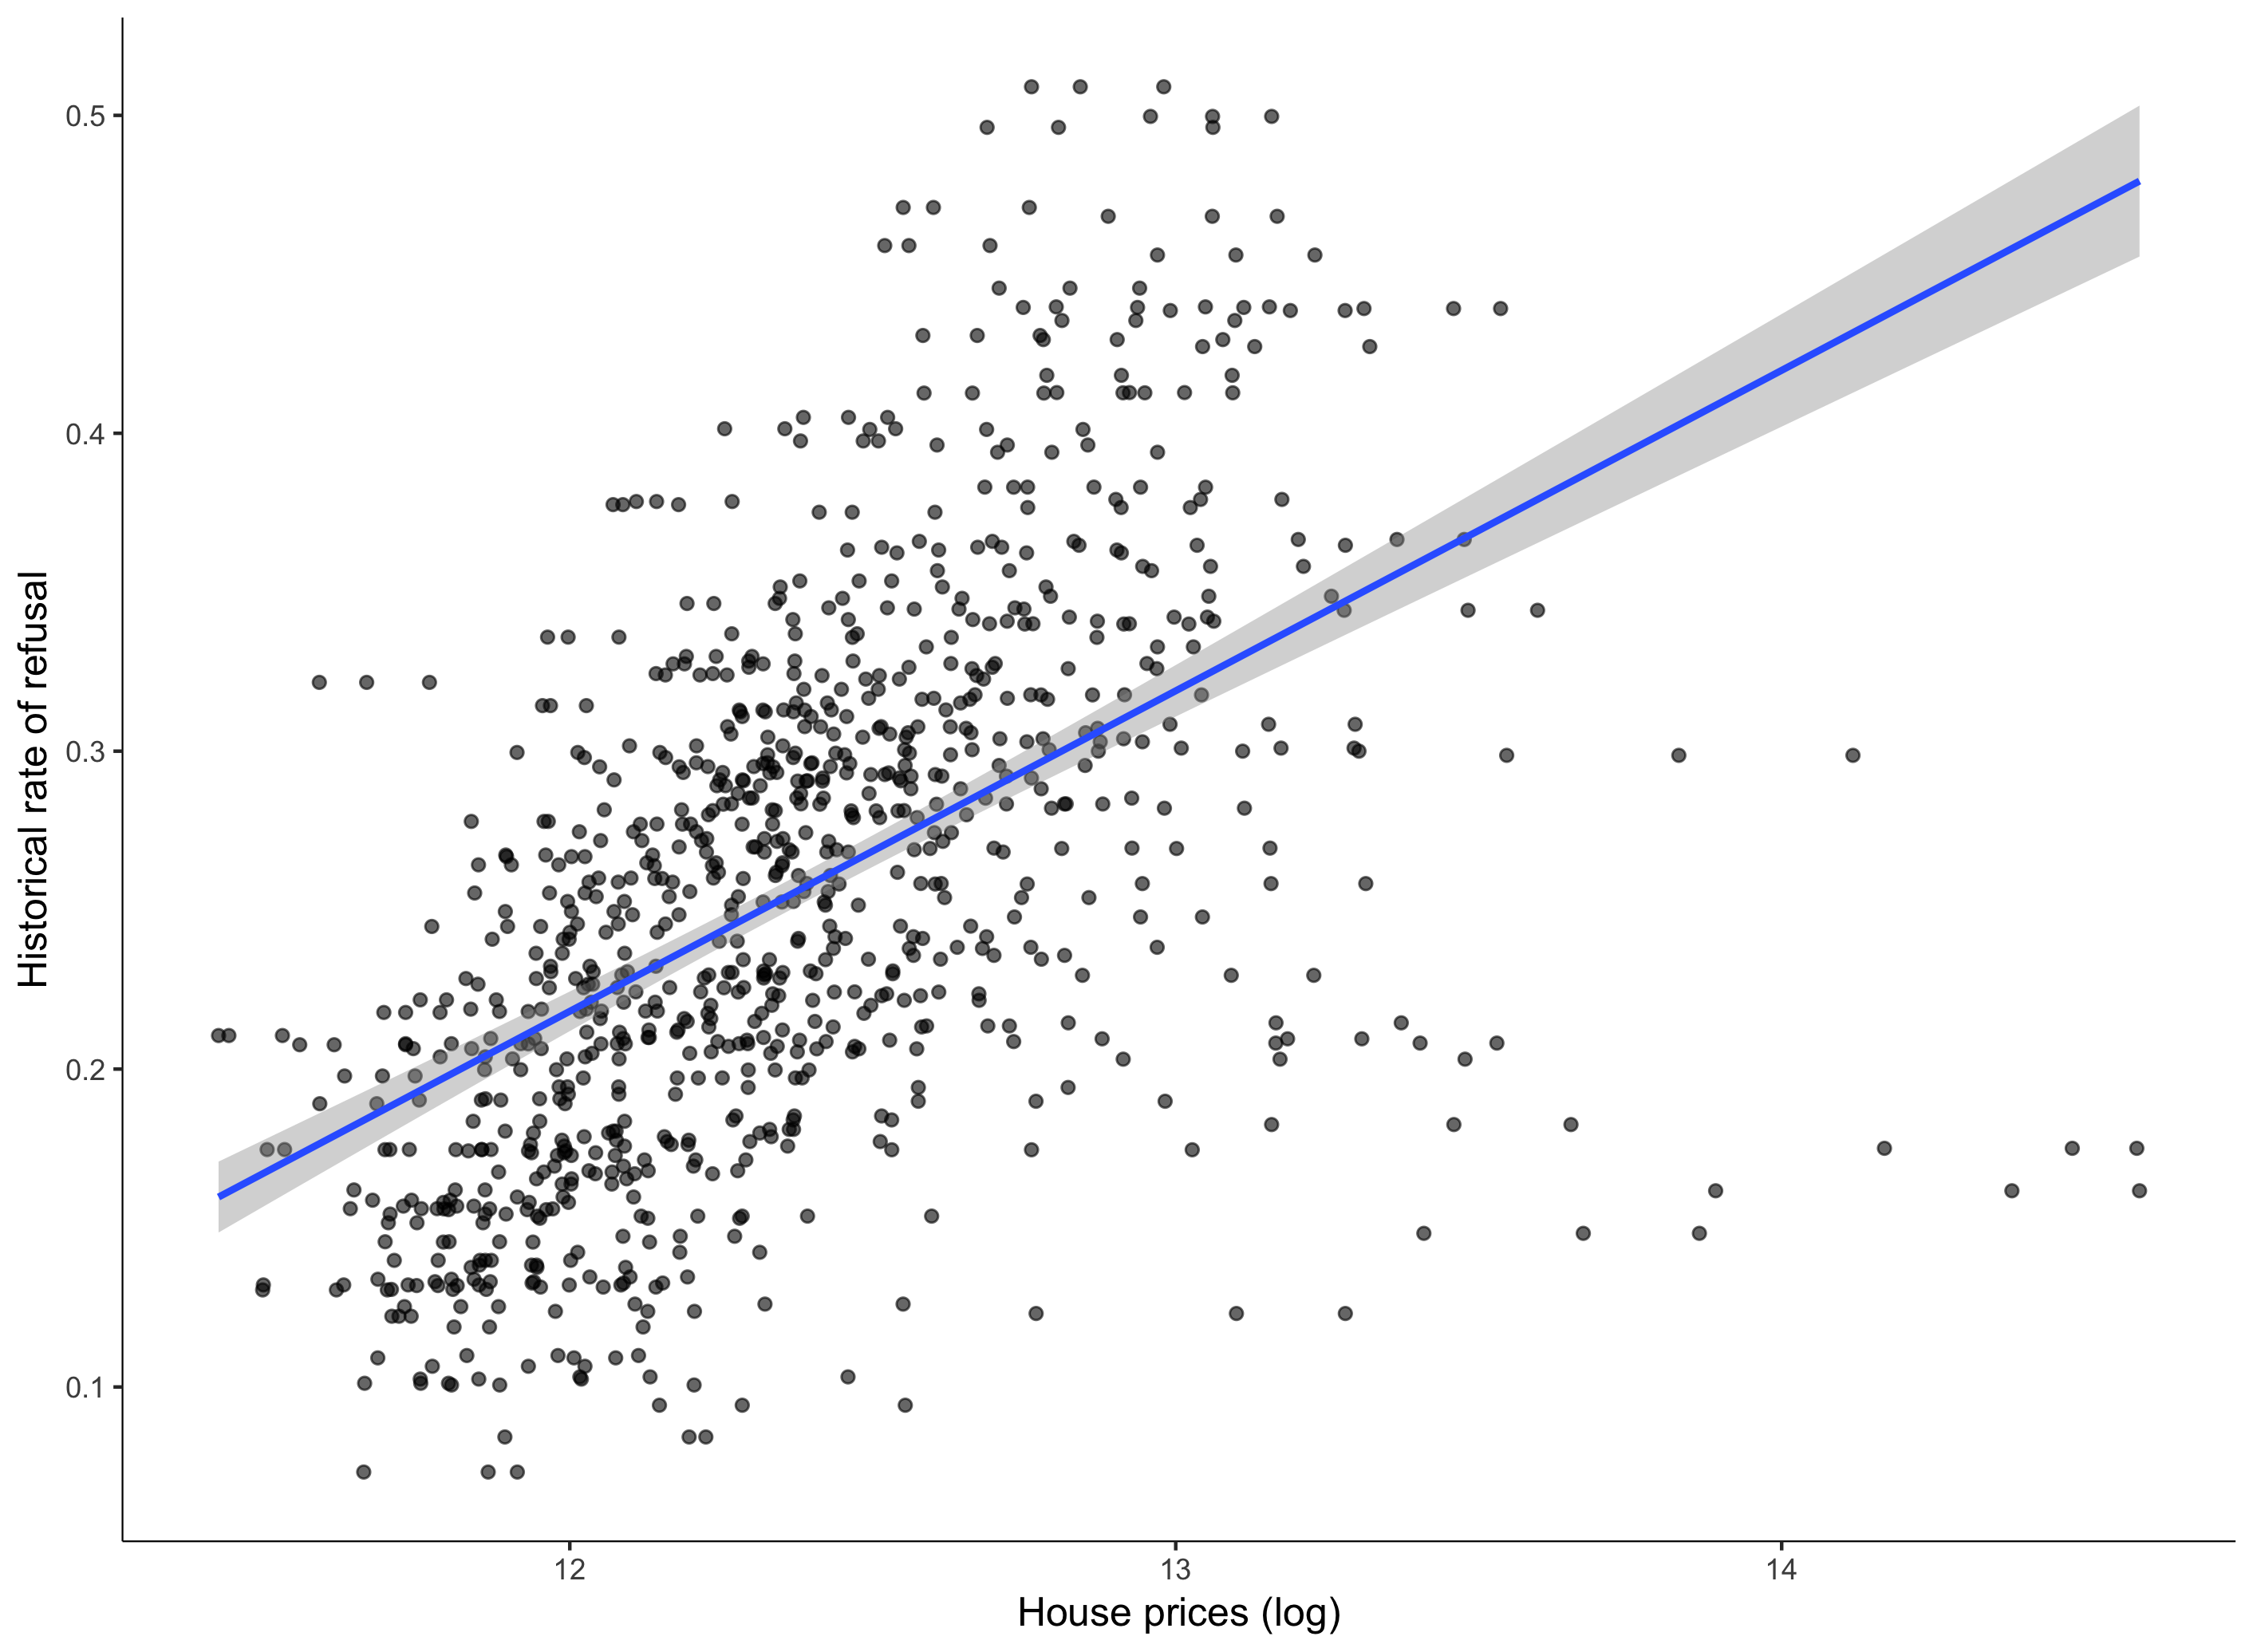

Figure 1: Correlation between urban planning restrictiveness and house prices

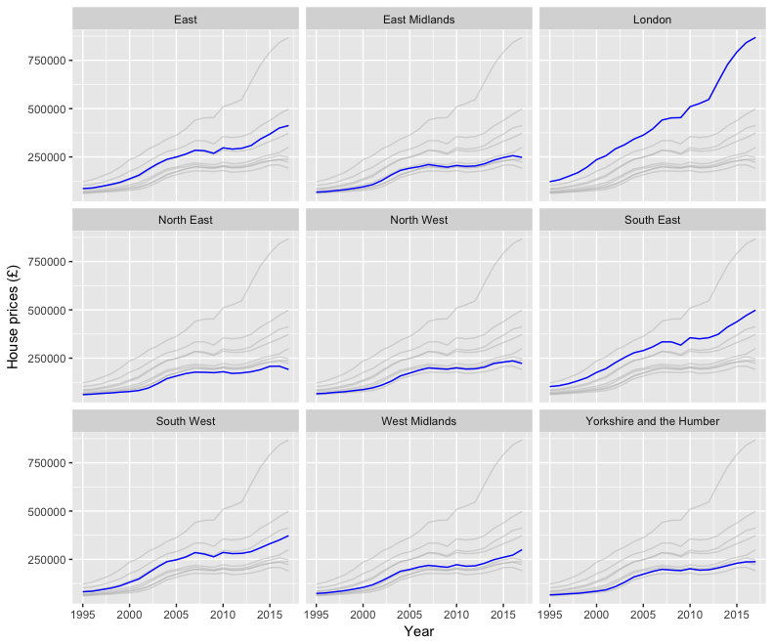

Figure 2: House prices in England, 1995-2017

Source: Office of National Statistics. House prices are deflated to 2000 prices.

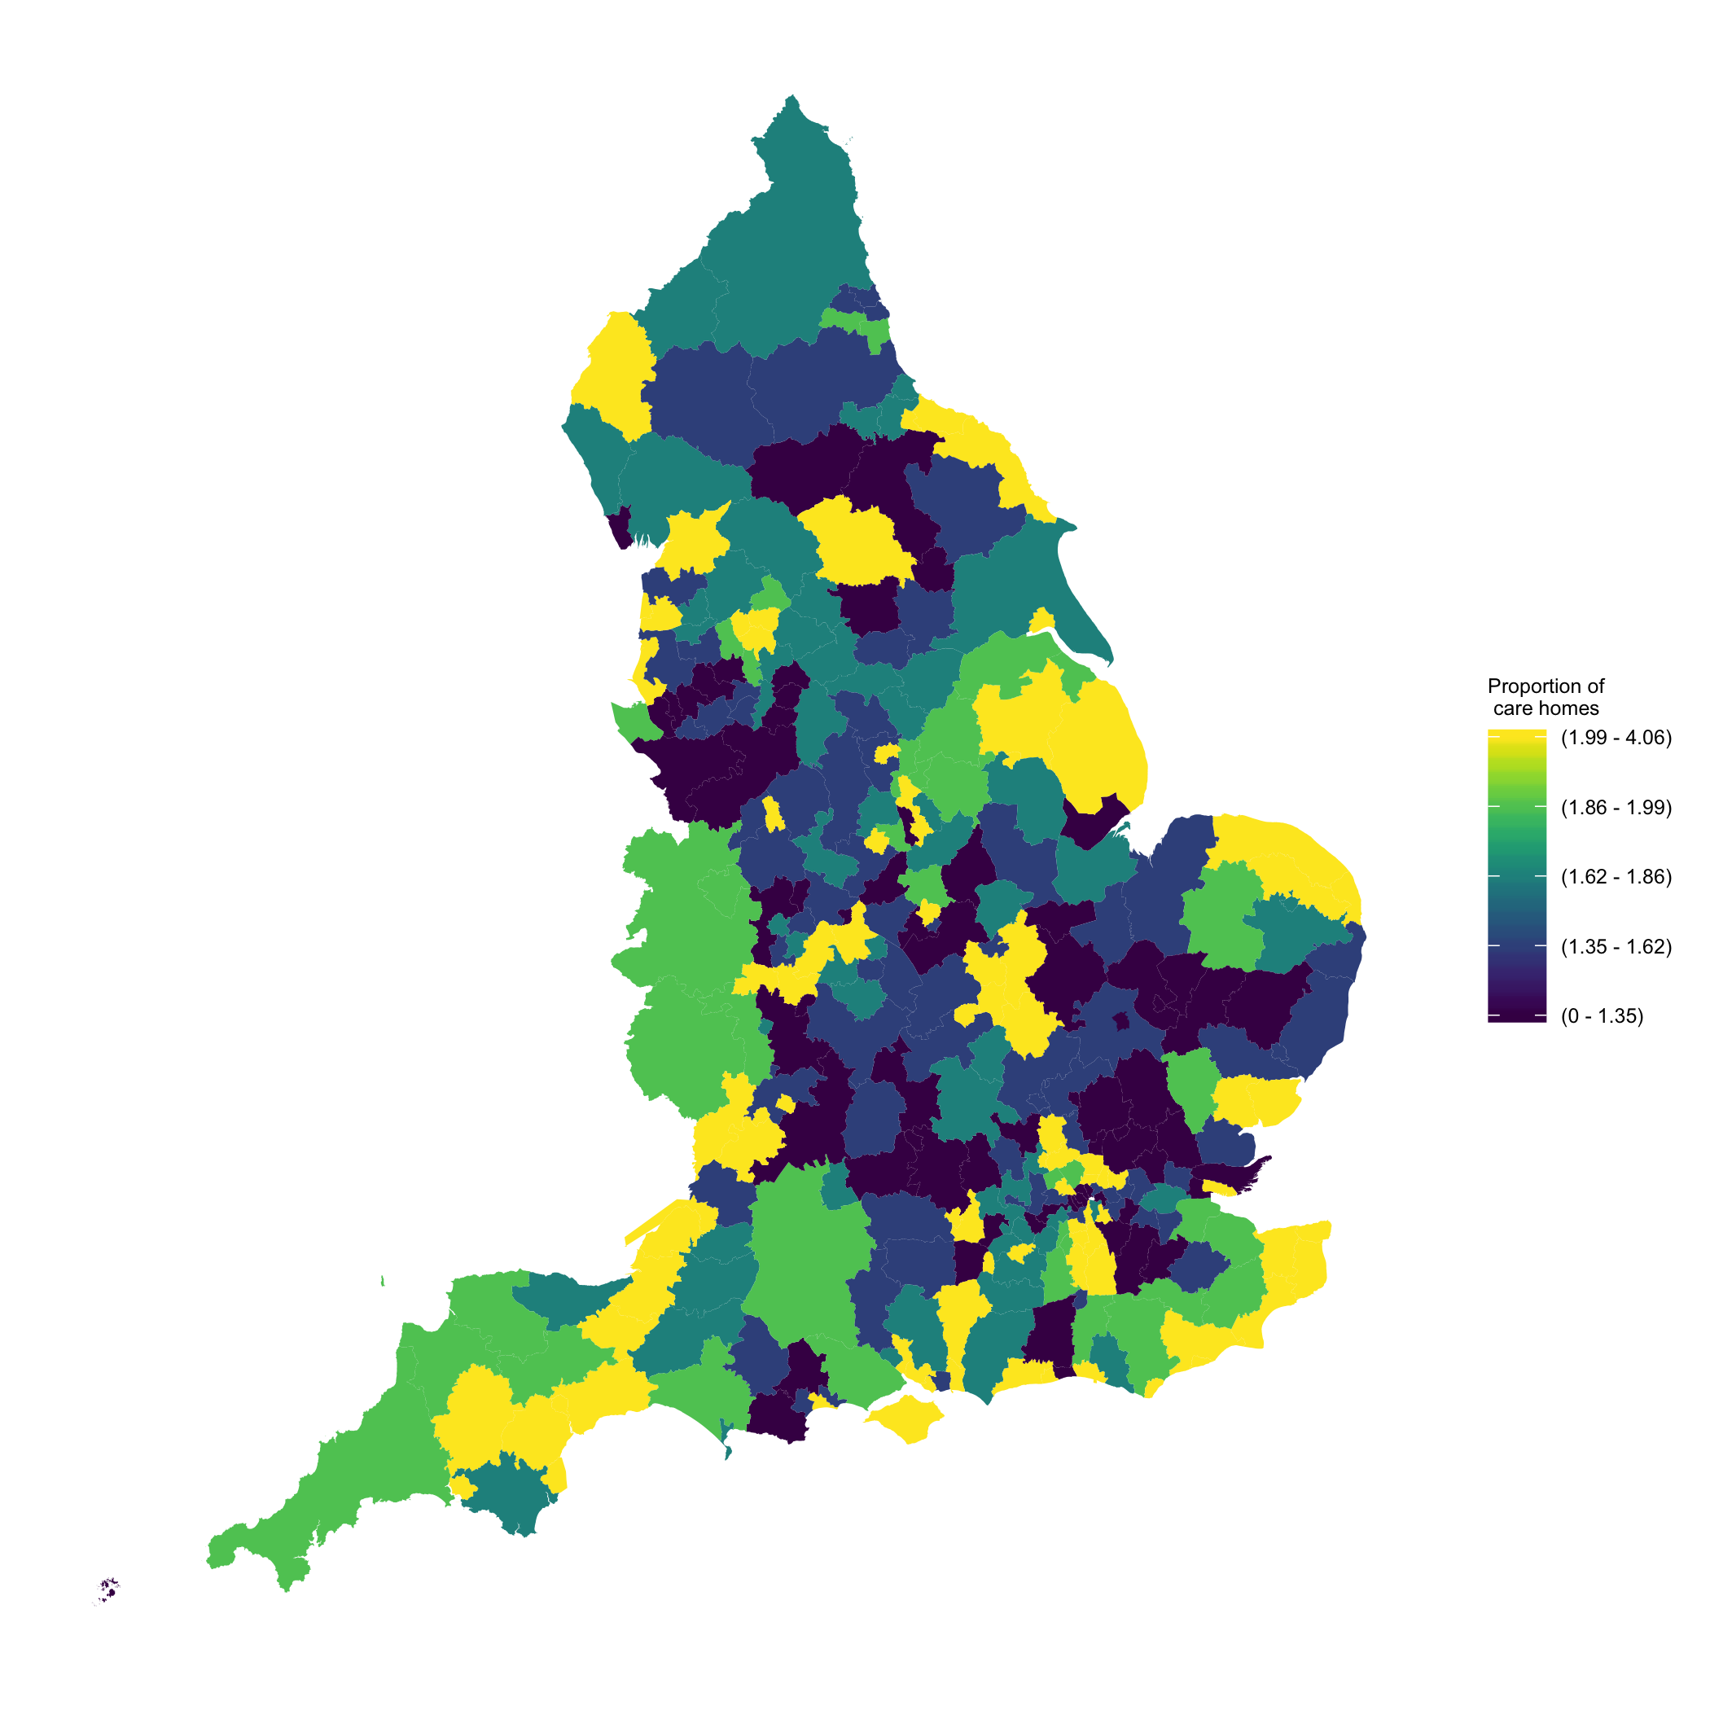

Figure 3: Care homes per 1000 population over 65 - England, district level

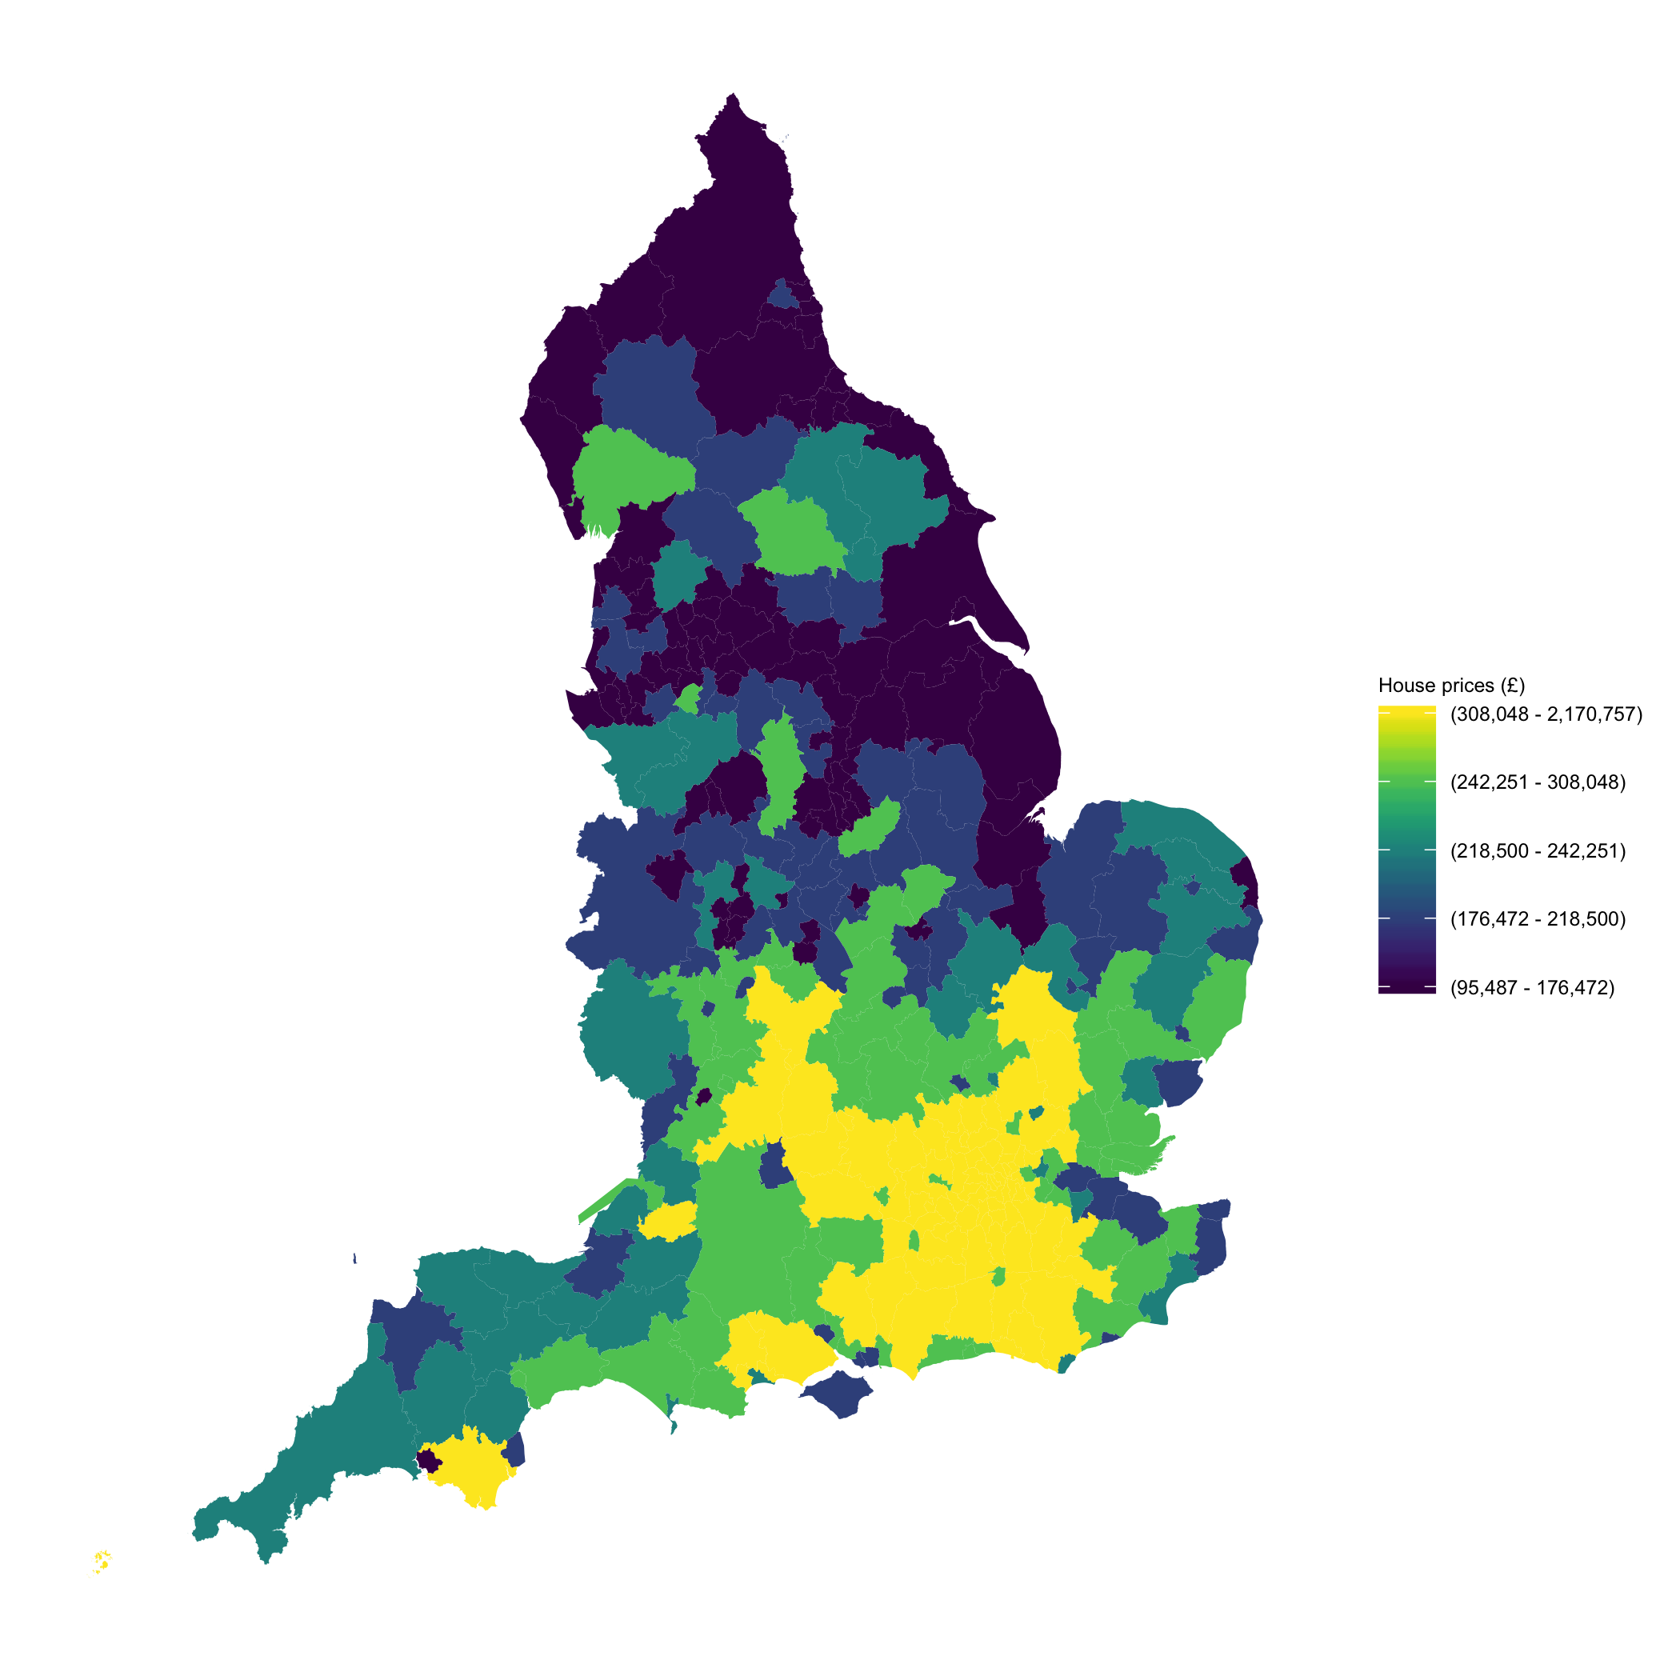

Figure 4: House prices - England, district level

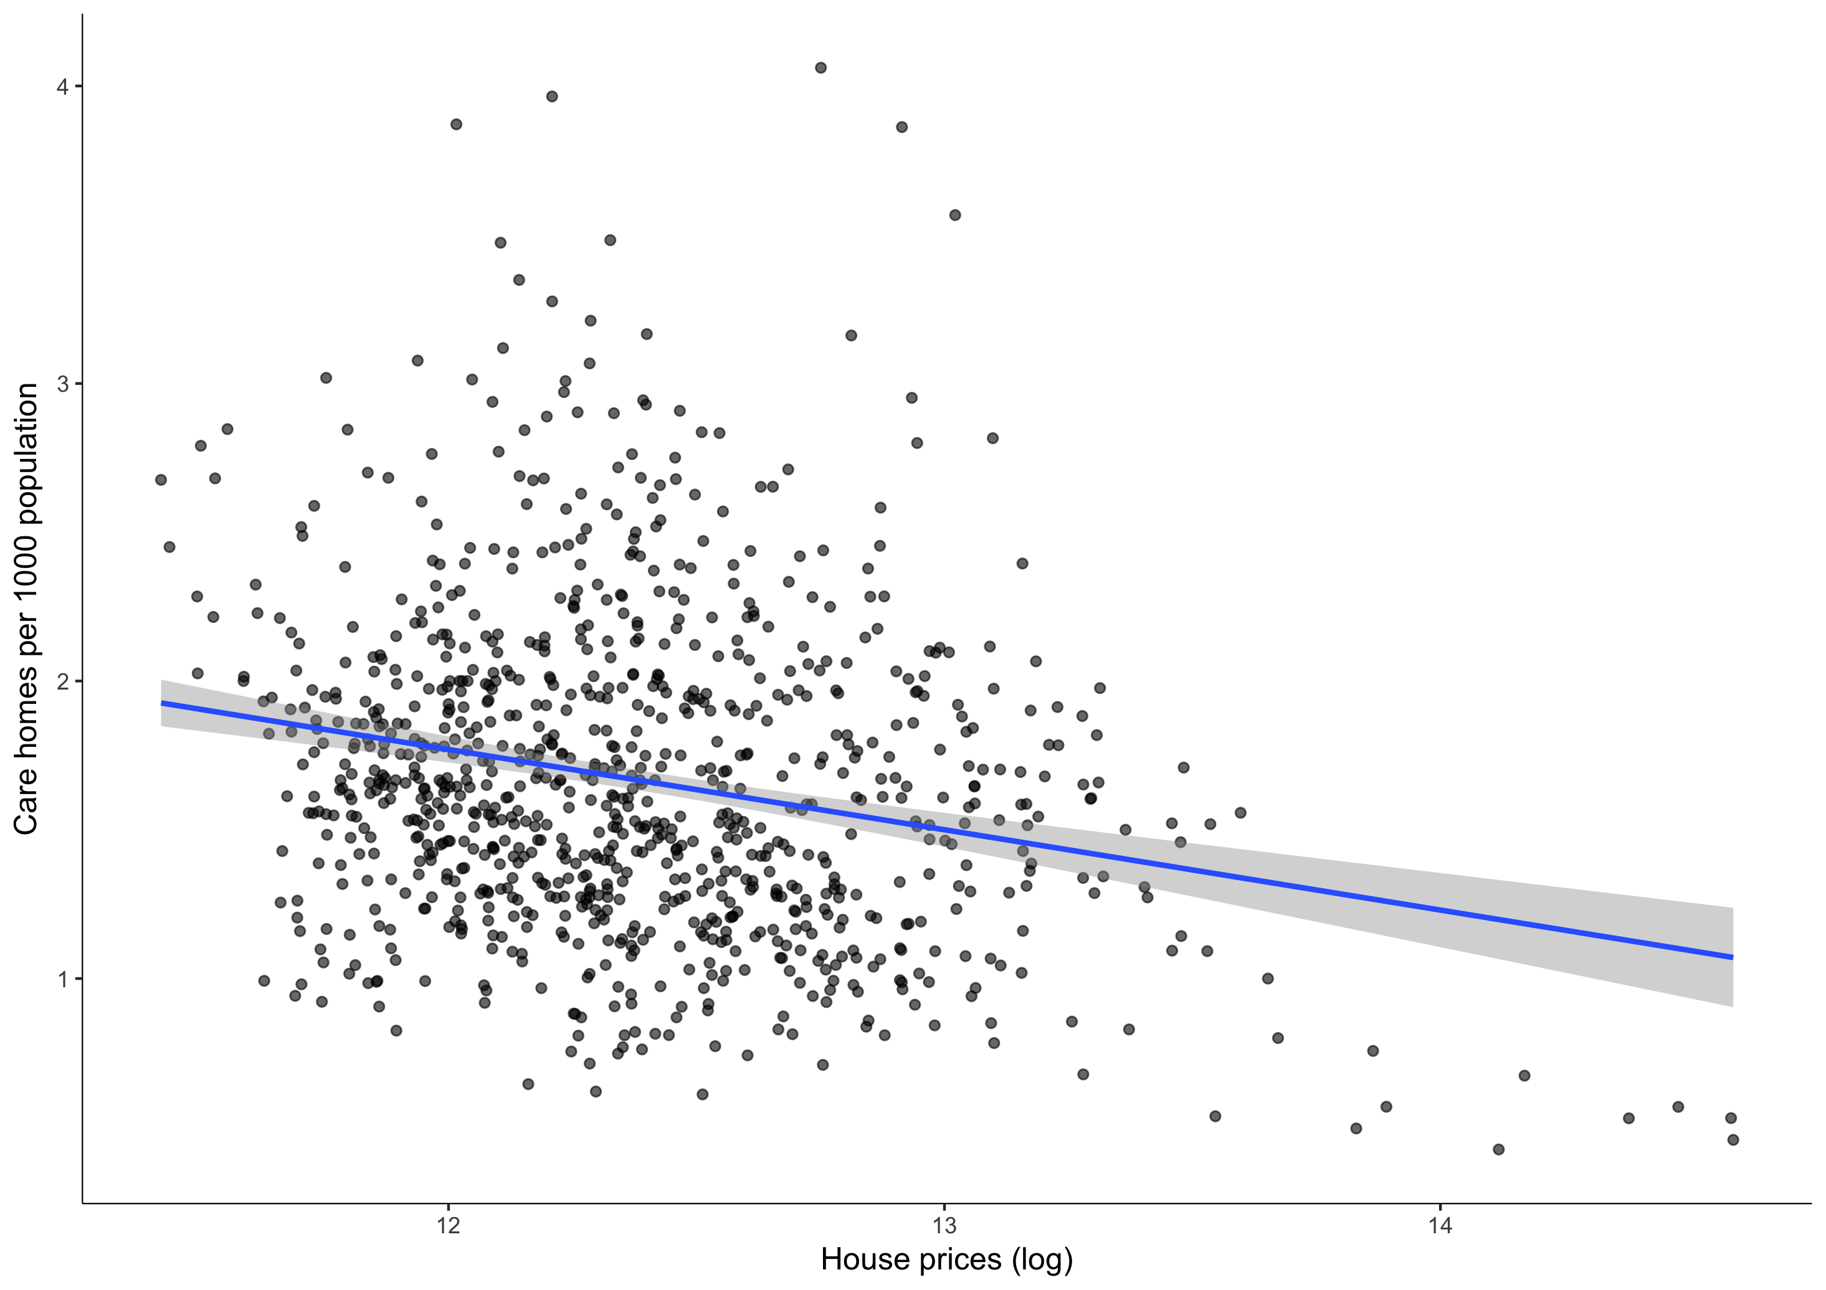

Figure 5: Correlation between care homes and house prices

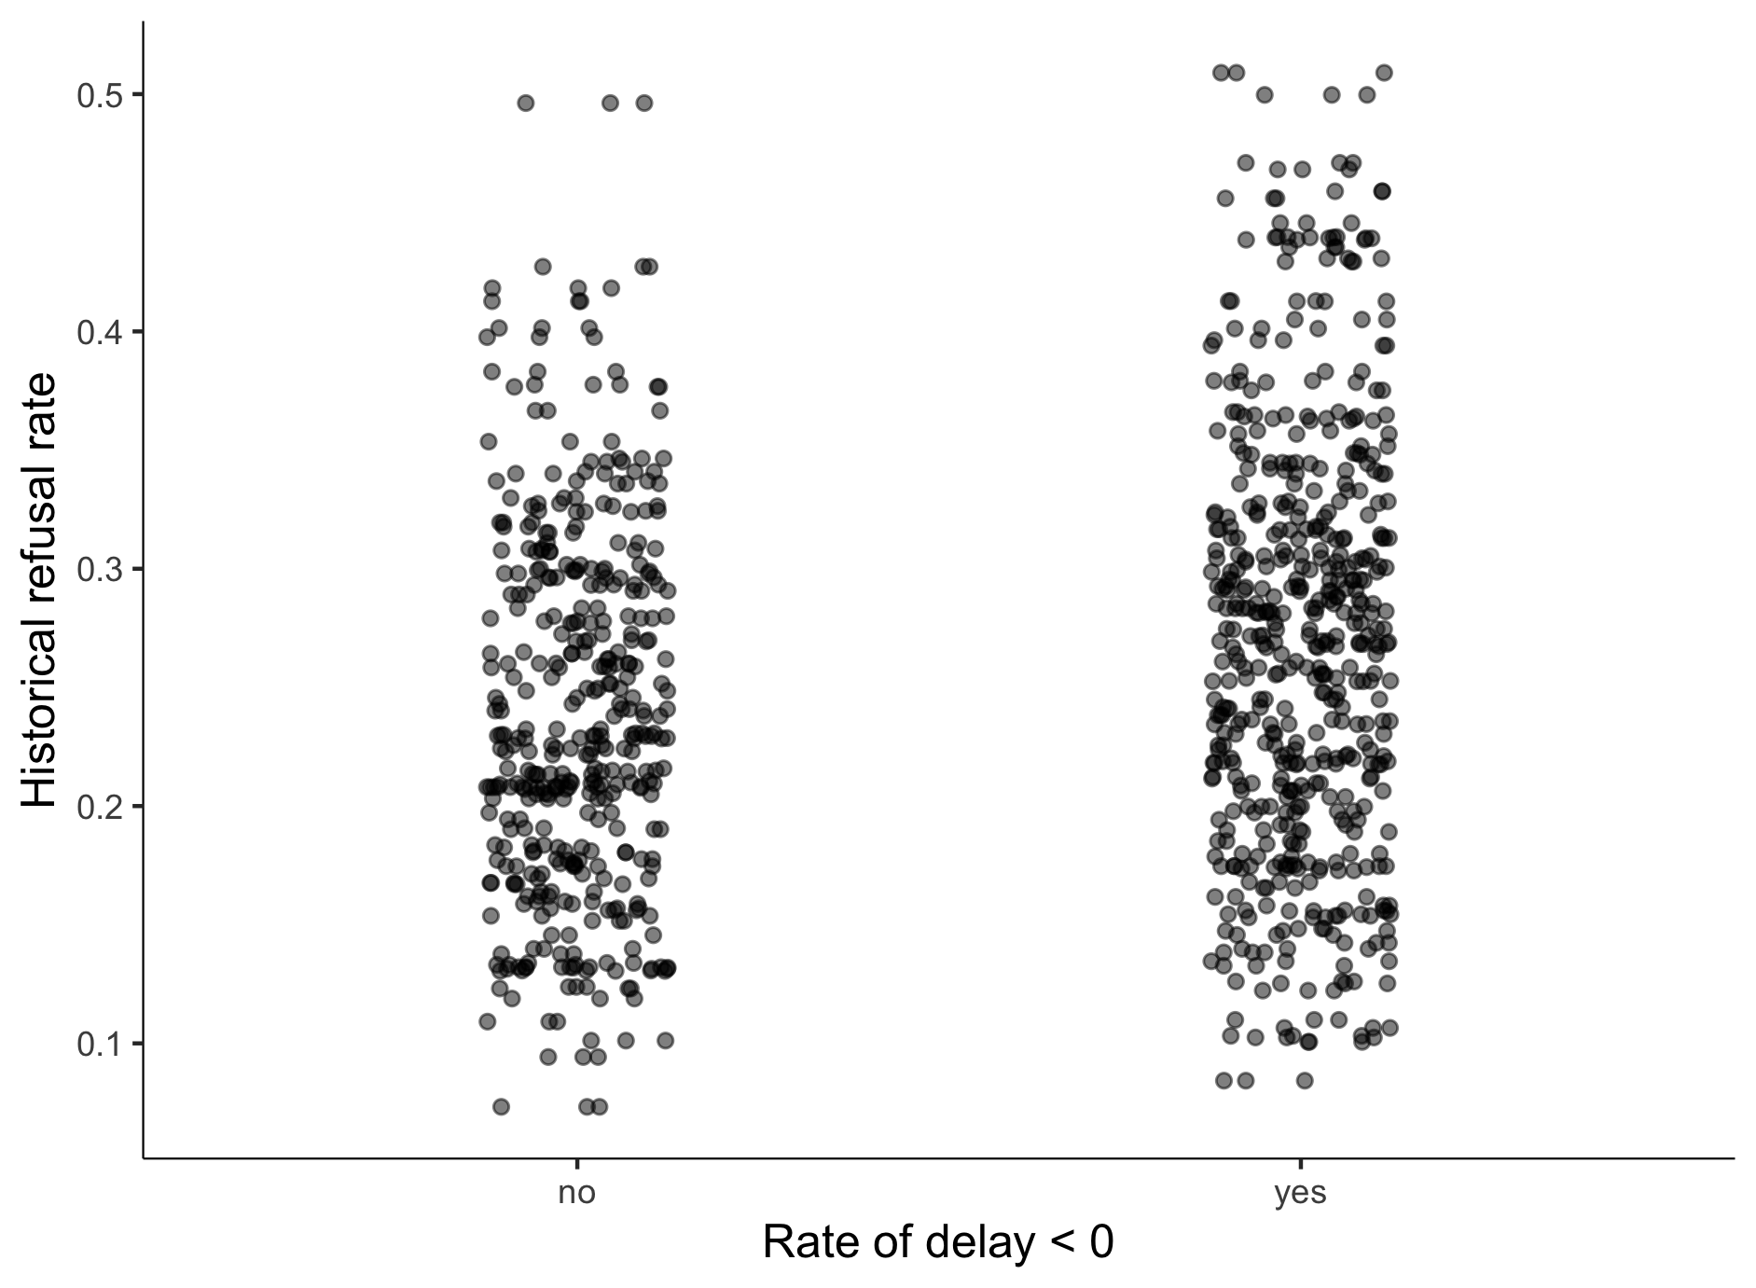

Figure 6: Distribution of refusal rates and rate of delay

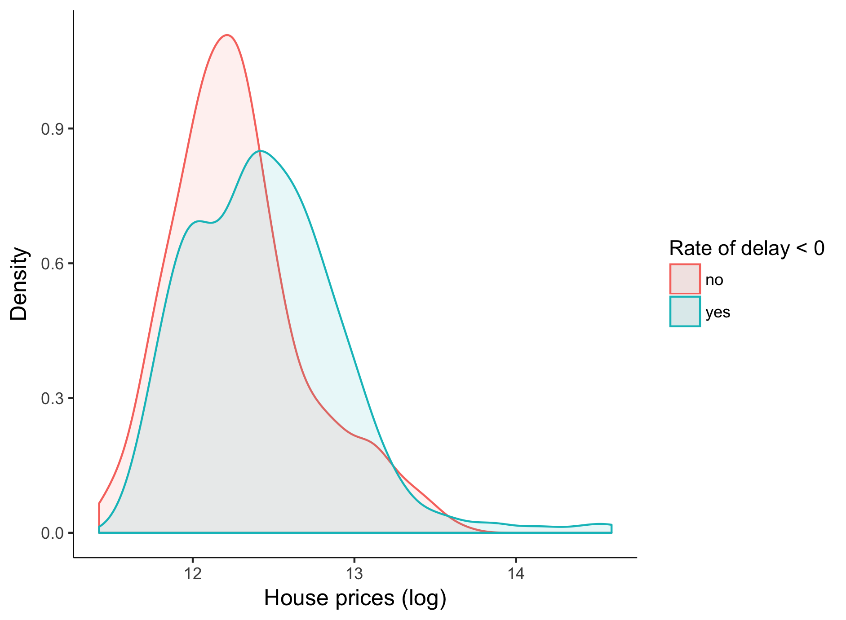

Figure 7: Distribution of house prices by rate of delay

1. Newcastle University Business School. 5 Barrack Rd, Newcastle upon Tyne NE1 4SE
2. Corresponding author: e.gonzalo-almorox@newcastle.ac.uk
3. Hilber (2017) refers particularly to their difficulty to access to mortgages, deposits or invest by means of a mortgage.
4. Some representatives of the sector argue that care home developers would be “*financially driven rather than reflecting the regional demand*”
5. Some areas of England have another tier that includes town and parish councils. This level of local government rules smaller local services.
6. Before 2008, these activities were managed by Primare Care Trusts (PCT). The Health and Social Care Act (2008) transferred public health matters – which included long term care activities among others, from these PCT to local authorities. Other issues where PCT were responsible for, such as clinical and health issues, became responsibility of the clinical commissioning groups (CCG).
7. Considering registered care homes in all sectors, the South East is the region that has more registered care homes (currently more than 1,000). This proportion of care homes contrasts with the North East where there are about 360 registered care homes.
8. This formula has been applied for the delivery of various public services in the UK . Using the nursing and residential care market, Barron and West (2017) analyse the performance in terms quality standards of different types of providers. Their main result suggests that facilities that operate in quasi markets are, on average, of higher quality.1 es have evaluated the effect e associatio g tions and the housing markets. e UK k for d importn for de in this course. Anothe
9. Using information from Laing Buisson market reports, Jarret (2017) argue that publicly funded clients would be about a 50% more than private clients in 2014.
10. This dataset is maintained by the CQC Directorate of Data and Statistics and available upon request.
11. Since October 2010 registration in Care Quality Commission became a legal requirement for every long term care provider wishing to carry out a regulated activity.
12. This situation is typically found when dealing with information contained in registries of firms. Neglecting it, apart from introducing measurement errors potentially, may lead to incorrect conclusions regarding the market dynamics and the performance of the firm. Geurts and Van Biesebroeck (2016), for instance, analyse the effect of this measurement problem on the estimations of the firm’s growth after the entry in the market
13. These dimensions entail the evaluation of issues related to the safety, the effectivity, the level of care and response to people’s needs as well as the management of the services.
14. The difference between these two types properties is based on the whether the ownership of the land or property is for a temporary (*leasehold*) or unrestricted (*freehold*) period.
15. Further information is provided in the following link: <http://www.data.parliament.uk/dataset/general-election-2015>
16. These districts are Allerdale, Lancaster, Harrogate and Scarborough.
17. The statistic resulting from this test is distributed as a distribution under the joint null hypothesis that the instruments are valid instruments.